## 6.7. Communications Management Plan

6.7.1. Introduction

The Communications Management Plan details the processes and strategies for communication that the project team and stakeholders of the SurveiRams project must follow. Planning this is important as communication between all stakeholders ensures good cooperation and a successful outcome that meets the project objectives.

The plan includes what approach the team is planning on using, as well as what might hinder effective communication among all stakeholders involved. The rest of the document discusses specific guidelines, agreements, and expectations on how communication will flow. The processes on how communication escalates within the hierarchy of all stakeholders depending on the need and reason are expounded on.

6.7.2. Communications Management Approach

The best communications management approach for the SurveiRams System project would be a combination of proactive and reactive strategies.

Proactively, regular project status meetings will be held to ensure all stakeholders are informed and aware of the project’s progress. The project manager will hold regular meetings with the project team and communicate any updates, progress reports, risks, and issues. This will provide stakeholders with an overview of the project’s status and any potential roadblocks. Additionally, a Microsoft Teams team will be created to provide stakeholders with easy access to project information, such as meeting minutes, documents, and project status reports.

Reactively, a clear and concise escalation process will be established to address any communication-based conflicts or issues that arise. The project manager will be readily available to stakeholders to answer any questions or concerns they may have and provide support and guidance when needed.

In addition, a change control process will be implemented to manage any changes in communication or the communication process. This will ensure that any changes are approved by the Change Control Board and that stakeholders are informed of any changes in a timely manner.

Overall, this approach ensures that the project team and stakeholders are kept informed and that any communication-based issues are handled in an efficient and effective manner.

6.7.3. Communications Management Constraints

There are some factors that could limit the communication processes among stakeholders in the project. Identifying these constraints will aid the project team in strategizing for mitigating and avoiding actions to ensure that the communication among them is efficient.

The following are the identified possible constraints:

|  |  |
| --- | --- |
| **Schedule of stakeholders** | The team members are students and most of the stakeholders are working full-time. Freeing time for meetings may be difficult. |
| **Technical Issues** | Online meetings are part of the communication methods. Device condition, internet connection, and technology literacy may affect the communication process. |
| **Time constraints** | The amount of communication between stakeholders might be low due to limited time to do so. |

6.7.4. Stakeholder Communication Requirements

The Stakeholder Communication Requirements portion of the document is vital for the project team and stakeholders to maintain a healthy professional relationship. It outlines the expectations and standards that all stakeholders are to uphold throughout the lifecycle of the project, which are the following:

|  |  |
| --- | --- |
| **Quick updates** | Should any progress, change, or risk arise, relevant stakeholders must be informed within 24-48 hours. |
| **Confidentiality** | Only relevant stakeholders will receive confidential information. |
| **Tailored communication** | Each stakeholder is different, so communication processes with them must be tailor-made to accommodate their needs. |
| **Two-way communication** | Stakeholders not only receive information but give their feedback as well. This could be about the deliverables or the project team themselves. |

6.7.5. Roles

|  |  |
| --- | --- |
| **Roles** | **Responsibilities** |
| Project Sponsor | The people who provide finances and input on what direction the project should go. They are also in charge of reviewing requests for any changes needed. |
| Project Manager | The person leading the team members from the initiation to the closing of the project. They make sure all deliverables are done on time without going over budget, and that the project objectives are met. |
| Documentation Team | The members of the project team who are responsible for the documents needed for the project. They also update them should any change occur. |
| Development Team | The members of the project team dealing with the actual development of the application. This could include the database and system architecture. |

*Table 6.7—1:Communication Management Roles and Responsibilities*

6.7.6. Project Team Directory

The following table presents contact information for all persons identified in this communications management plan. The email addresses and phone numbers in this table will be used to communicate with these people.

|  |  |  |  |  |
| --- | --- | --- | --- | --- |
| **Name** | **Position** | **Internal, External** | **Project Role** | **Contact Information** |
| Jose Manuel Garcia | Campus Architect | Internal | Project Sponsor | manoletg@apc.edu.ph |
| Jojo Castillo | ITRO Head | Internal | Project Sponsor | jojoc@apc.edu.ph |
| Ian Christopher Onrubia | Project Manager | Internal | Project Manager | iconrubia@student.apc.edu.ph |
| Jan Karlo Boongaling | Documentation Specialist | Internal | Documentation Team | jmboongaling@student.apc.edu.ph |
| Alexis Martin | Quasar Front-end Developer | Internal | Development Team | atmartin@student.apc.edu.ph |
| Vladimir Ken Perez | Back-end Developer | Internal | Development Team | viperez@student.apc.edu.ph |
| Yuan Alexandrei Serafico | Software Tester | Internal | Documentation Team | yaserafico@student.apc.edu.ph |

*Table 6.7—2: Project Team Directory*

6.7.7. Communication Methods and Technologies

To prevent misunderstandings, the team needs to be open with each other and the stakeholders. The team must inform the stakeholders of the project's status on a regular basis to avoid misunderstandings. The stakeholders will need information, including reports, issues, and updates for them to understand what is happening in the project.

Factors to be considered in determining the best communication methods and technologies for the SurveiRams system:

**Stakeholder’s Preference**

Stakeholders may prefer to meet online or face-to-face. It really depends on what mode of communication they want. Either way, if they want to meet online, the team may set a meeting through Microsoft Teams.

**Type of Information**

The team may just send an email with the links of their documents for the stakeholders to consult with that does not require a meeting. This includes weekly updates, reports, and issues.

**Budget and Resources Available**

The chosen method of communication should be aligned with the budget .

Therefore, the SurveiRams System suggests using a combination of project management software, email, and video conferencing apps like Microsoft Teams to keep the stakeholders updated and achieve the project's goals.

6.7.8. Communications Matrix

|  |  |  |  |  |
| --- | --- | --- | --- | --- |
| **Communication** | **Purpose** | **Medium** | **Frequency** | **Audience** |
| Project  Planning | To establish a solid base and maintain the team's focus and progress | OpenProject, Meeting | Once Before the start of the project | Project Manager  Project Team  Project Sponsor |
| Release planning | To manage dependencies | OpenProject, Meeting | Once every month | Project Manager  Project Team  Project Sponsor |
| Monthly Sprint  Planning | To determine monthly goal | OpenProject, Meeting | Once before starting another feature | Project Manager  Project Team  Project Sponsor |
| Management  processes | To ensure there is coordination in the team | Email, OpenProject | Once every week | Project Manager  Project Team  Project Sponsor |
| Product backlog | Inform stakeholders the tasks that has not been processed and need to be addressed | Email/ Meeting | When necessary | Project Manager  Project Sponsor |
| Project Consultation | Enhance project by having stakeholder’s guidance and comments | Meeting | Once every week | Project Manager  Project Team  Project Sponsor |
| Project Update | Weekly update on the progress of the project | Email | Once every week | Project Manager  Project Team  Project Sponsor |

*Table 6.7—3: Communication Matrix*

6.7.9. Communication Flowchart

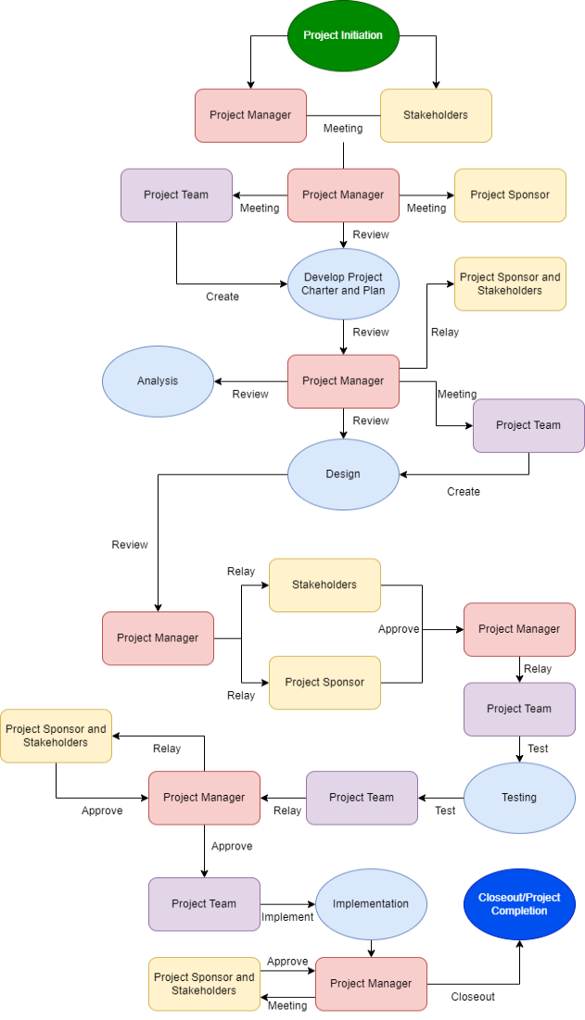

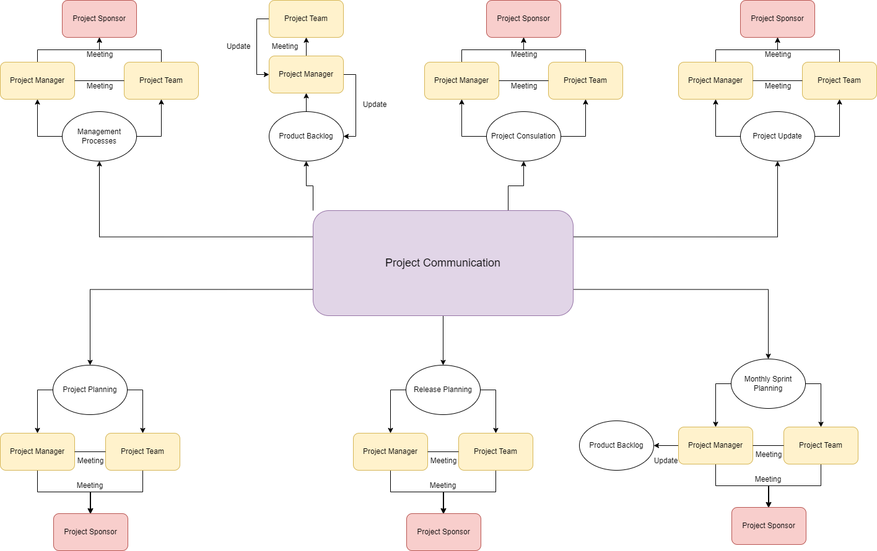

6.7.10. Guidelines for Meetings

The principles and recommendations in meeting guidelines serve to ensure successful meetings. These will serve as the project team's meeting protocol guidelines. encouraging interaction, participation, and successful outcomes. Project SurveiRams is not an exception, setting up clear meeting rules is crucial for ensuring that meetings are efficient, effective, and productive.

Having clearly outlined meeting guidelines enables project team members and stakeholders to come well-prepared and actively engage in discussions, enhancing their participation. Furthermore, it allows the project manager to maintain consistency and organization throughout meetings, preventing any potential confusion or misunderstandings.

The following guide is to help the project team to initiate a successful meeting:

* **Define Clear Objectives:** Start by clarifying the purpose and objectives of the meeting. Clearly communicate what you aim to accomplish. Ensure that all participants are aware of the desired outcomes.
* **Prepare an Agenda:** Create a well-structured agenda that outlines the topics to be discussed, the time allocated for each item and any necessary materials or preparations.
* **Start and End on time:** Punctuality is crucial for effective meetings. Begin the meeting promptly at the scheduled time, regardless of whether all participants are present. Respect everyone's time by ending the meeting on time.
* **Encourage active participation:** Create an environment that encourages people to participate and speak. Encourage diverse perspectives, ask open-ended questions, and provide opportunities for everyone to contribute.
* **Allocate time effectively:** Allocate sufficient time for each agenda item, considering its importance and complexity. Prioritize critical discussions and be mindful of time constraints. If needed, table less urgent topics for subsequent meetings.
* **Document key points and action items:** Assign someone to document the meeting minutes or key takeaways. Capture important decisions, action items, and responsibilities assigned to individuals. Share the minutes with participants after the meeting to ensure everyone is aligned.
* **Follow up on action items:** Monitor progress on action items and provide updates in subsequent meetings. Hold individuals accountable for their assigned tasks and track their completion. This ensures that the outcomes of the meeting are implemented effectively.

By adhering to these meeting guidelines, the project team can enhance the efficiency, collaboration, and overall effectiveness of your meetings, leading to better outcomes and stronger teamwork.

6.7.11. Communication Standards

The best communication standards for the SurveiRams project may include the following:

* **Regular Team Meetings:** Schedule regular team meetings mostly once or twice a week to discuss project progress, address challenges, and ensure everyone is aligned. These meetings can be conducted in person or remotely, depending on the team's location.
* **Active listening:** Engage in attentive listening, focusing on understanding others' perspectives and ideas. Avoid interrupting and demonstrate respect for the speaker by giving them your full attention.
* **Clear and concise expression:** Express your thoughts and ideas clearly, using simple and concise language. Avoid jargon or overly technical terms that may confuse others.
* **Respectful dialogue:** Foster a respectful and inclusive environment where all participants feel comfortable expressing their opinions. Treat others with courtesy and avoid engaging in personal attacks or disrespectful behavior.
* **Constructive feedback:** Provide feedback in a constructive and tactful manner, emphasizing specific points and suggestions for improvement. Avoid overly critical or negative language that may hinder collaboration.
* **Clarity in questioning:** Ask clear and relevant questions to seek clarification, gather information, or prompt deeper discussion. Avoid vague or ambiguous questions that may lead to confusion.
* **Summarize and recap:** Periodically summarize key points and takeaways from the discussion to ensure everyone is on the same page. This helps consolidate information and maintain focus throughout the meeting.
* **Follow up:** After the meeting, ensure that any action items or decisions are documented and communicated to relevant parties. Take responsibility for assigned tasks and provide updates as necessary.
* **Communication Channels:** Establish clear channels of communication for the project team, such as email, instant messaging platforms, project management tools, or collaboration software. Ensure that everyone knows which channels to use for different types of communication.
* **Documentation:** Emphasize the importance of documenting project-related information. This includes maintaining a project repository for code and design assets, documenting requirements, technical specifications, meeting minutes, and any decisions made during the project.
* **Status Updates:** Regularly provide status updates on project milestones, progress, and any blockers or challenges. This can be done through project management tools, email, or shared documents. Transparent and timely communication helps the team stay informed and take necessary actions.

6.7.12. Communication Escalation Process

The ideal and best communication escalation process for the SurveiRams project would involve the following steps:

1. **Direct Communication:** Encourage team members to communicate directly with each other for routine project-related matters. This includes discussions about tasks, progress updates, and minor issues.
2. **Team Lead/Manager Involvement:** The next step is to include the appropriate team lead or manager if a communication problem persists or if team members are unable to fix it on their own. The team leader or manager may facilitate the conversation, clear up any confusion, and assist in coming to a decision.
3. **Project Manager/Project Sponsor Involvement:** If the issue remains unresolved or requires higher-level intervention, it should be escalated to the project manager or project sponsor. The project manager or sponsor will assess the situation, provide guidance, and take necessary actions to address the issue.
4. **Project Stakeholder Involvement:** In cases where the issue involves project stakeholders, such as clients or end-users, and it cannot be resolved at the team level, escalate the matter to the project stakeholder(s). This may include scheduling a meeting or providing a detailed written report outlining the issue and the attempts made to resolve it.
5. **Post-Incident Review:** After a communication issue has been resolved, conduct a post-incident review to analyze the root cause, identify areas for improvement, and implement any necessary corrective or preventive actions. This review helps prevent similar communication issues in the future.

It's important to note that the escalation process should be flexible and adaptable to the specific needs of the project. The project team should review the escalation process regularly to ensure that it remains effective and efficient in addressing communication related issues.

6.7.13. Glossary of Communication Terminology

|  |  |
| --- | --- |
| **Term Definition** | |
| **Team Meetings** | Scheduled Gatherings of the project team |
| **Active Listening** | Engaging in attentive listening to understand others' perspectives without interruption. |
| **Constructive Feedback** | Providing Feedback in a tactful and helpful manner to promote improvement. |
| **Non-verbal cues** | Observing and Interpreting body language and facial expressions to understand reactions and sentiments. |
| **Follow-up and Follow-through** | Documenting action items, decisions and ensuring their completion. |
| **Post-Incident Review** | A review after resolving a communication issue to analyze the root cause, identify areas for improvement, and implement necessary corrective or preventive actions. |
| **Project Manager** | The individual responsible for planning, executing, and overseeing a project from initiation to completion, including managing resources, risks, and stakeholders. |
| **Project Management** | The application of knowledge, skills, tools, and techniques to achieve project objectives within defined constraints, such as scope, time, cost, and quality. |
| **Communication Standards** | Standard templates, formats, or documents used for communicating within a project. |
| **Project-related matters** | Tasks, issues, updates, materials that are related to the project |
| **Communication Channels** | Is where the team can communicate whether personally or through software applications like MS teams, Facebook Messenger, Discord etc., |
| **Documentation** | All documents related to the project |

*Table 6.7—4: Glossary of Communication Management Terminologies*